|  |  |  |
| --- | --- | --- |
|  | || Jai Sri Gurudev ||  ADICHUNCHANAGIRI INSTITUTE OF TECHNOLOGY ,CHIKKMAGALURU  Department of Information Science & Engineering |  |

4.1.3 Number of classrooms and seminar halls with ICT- enabled facilities such as smart class, LMS, etc

1. ISE Classrooms (67 sqm)

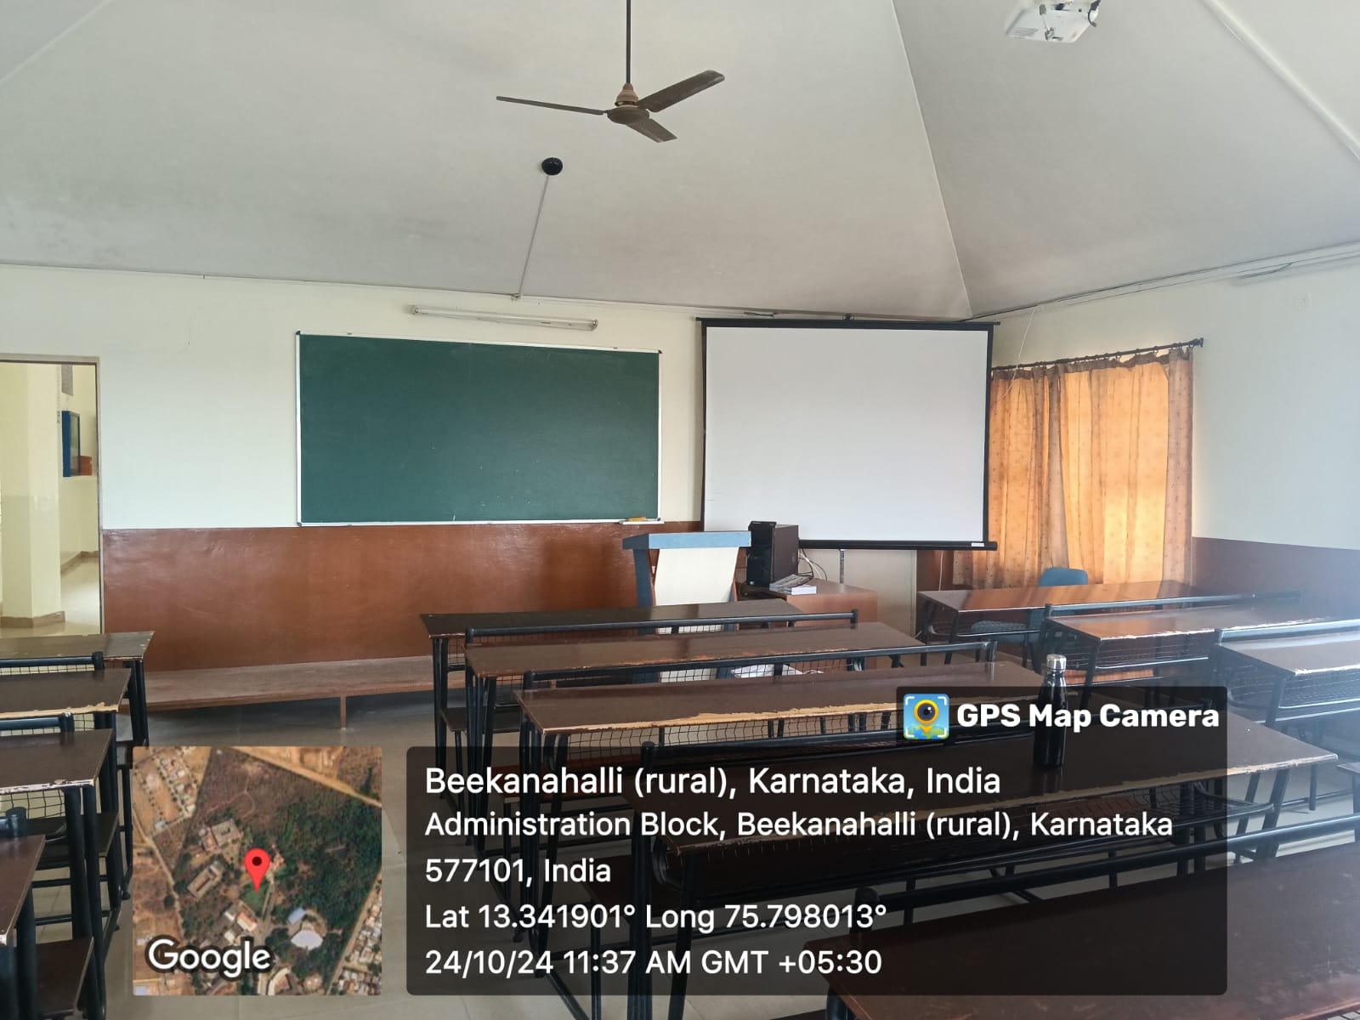

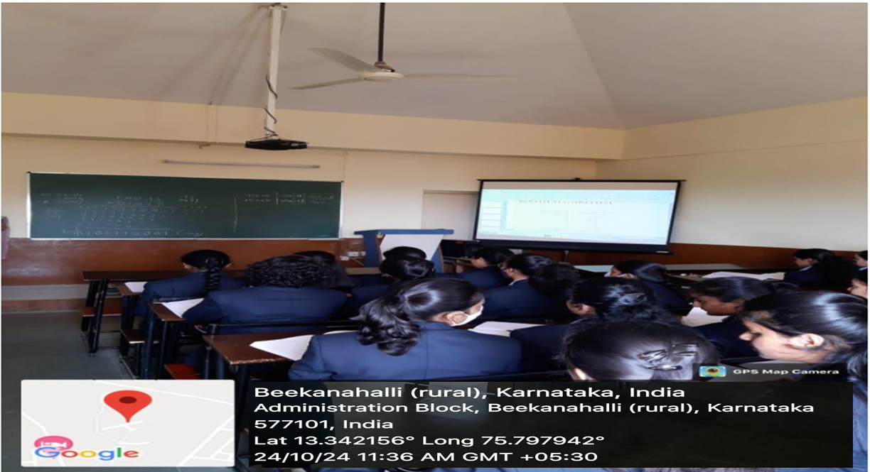

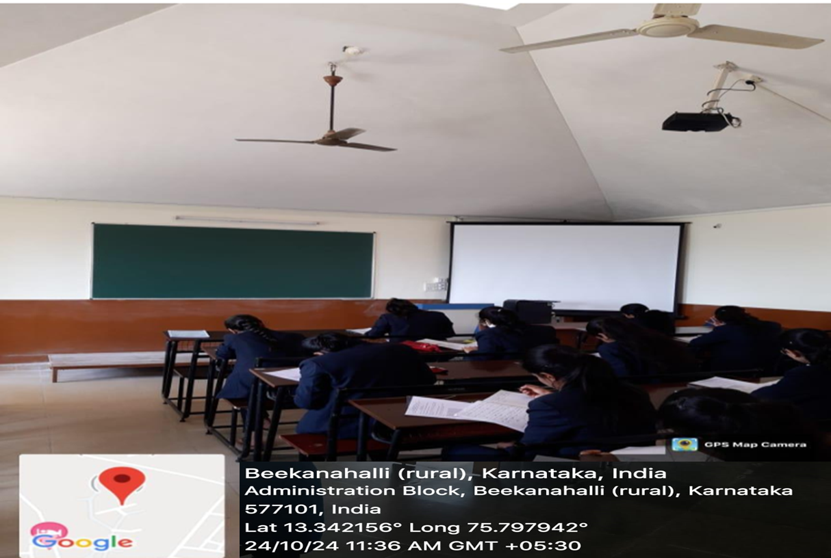

2. ISE Laboratories (70 sqm)

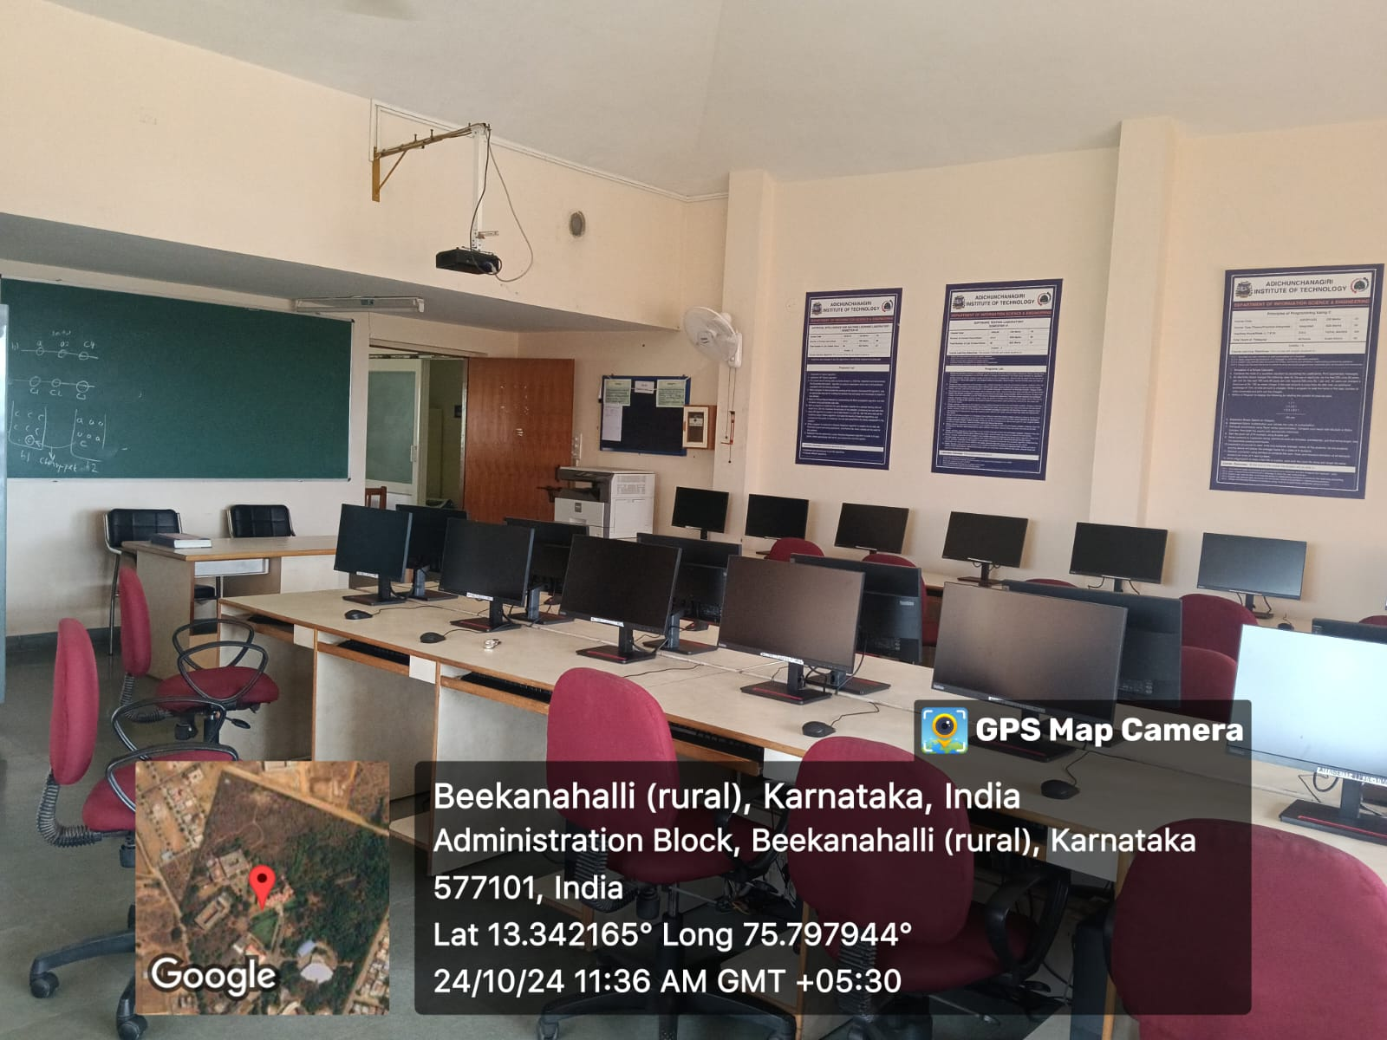

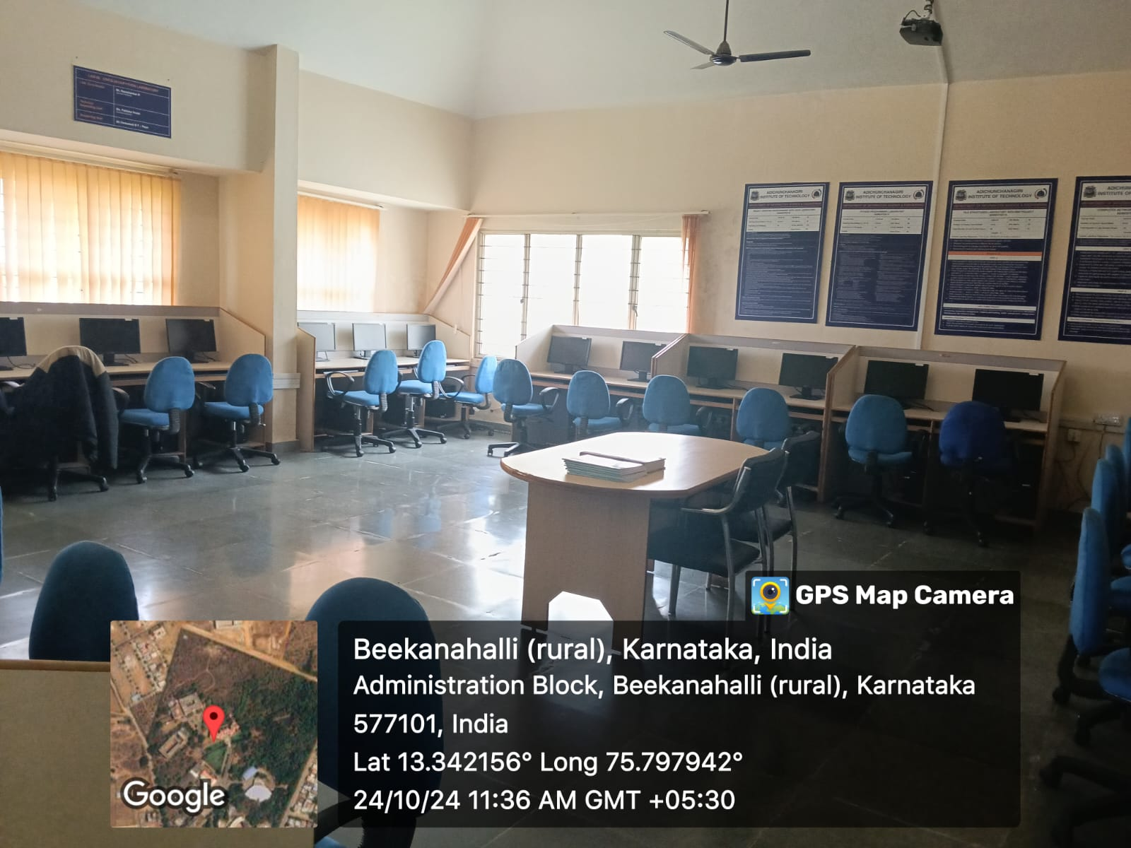

3. ISE Seminar Hall (105sqm)

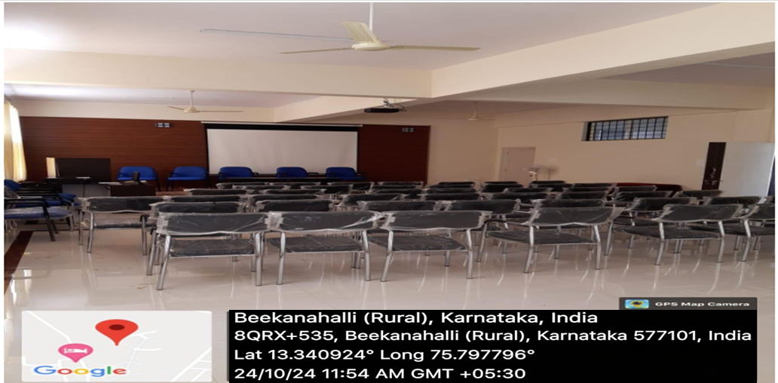

4. ISE VGST Granted Lab (70 sqm)

