**Adichunchanagiri Institute of Technology, Chikmagalur**

**Department of Mechanical Engineering**

**Blood Donation Camp**

**19th May 2021**

Blood Donation Camp was organized by the department of Mechanical Engineering on 19th May 2021

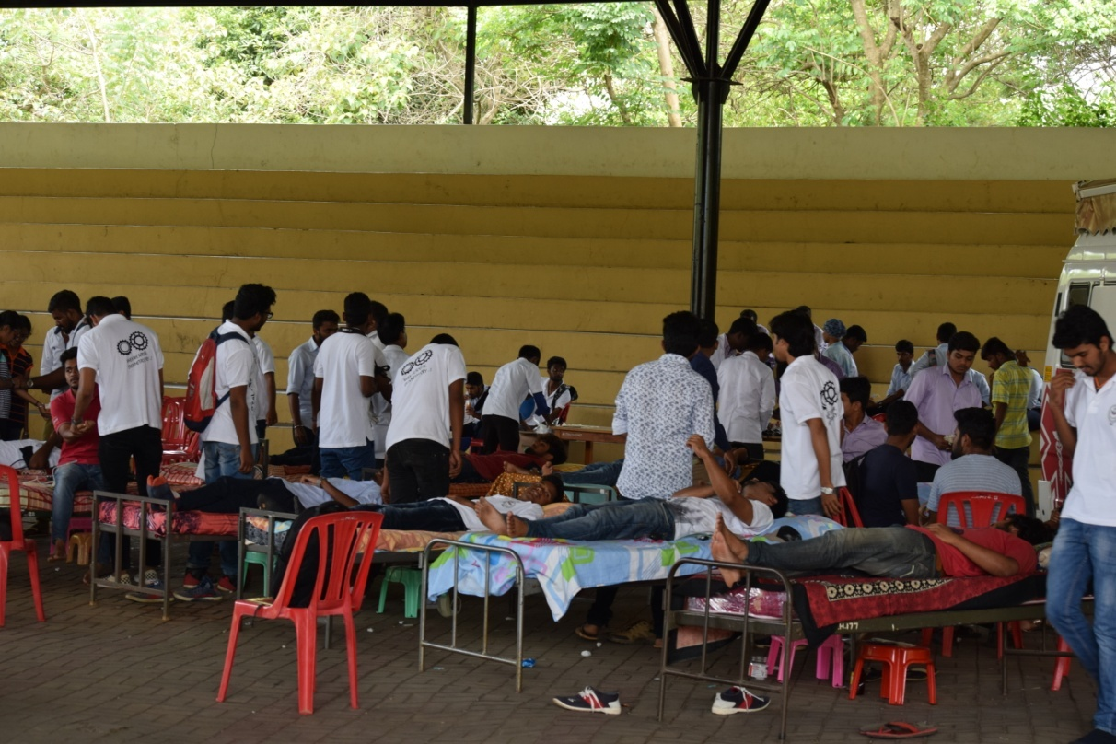

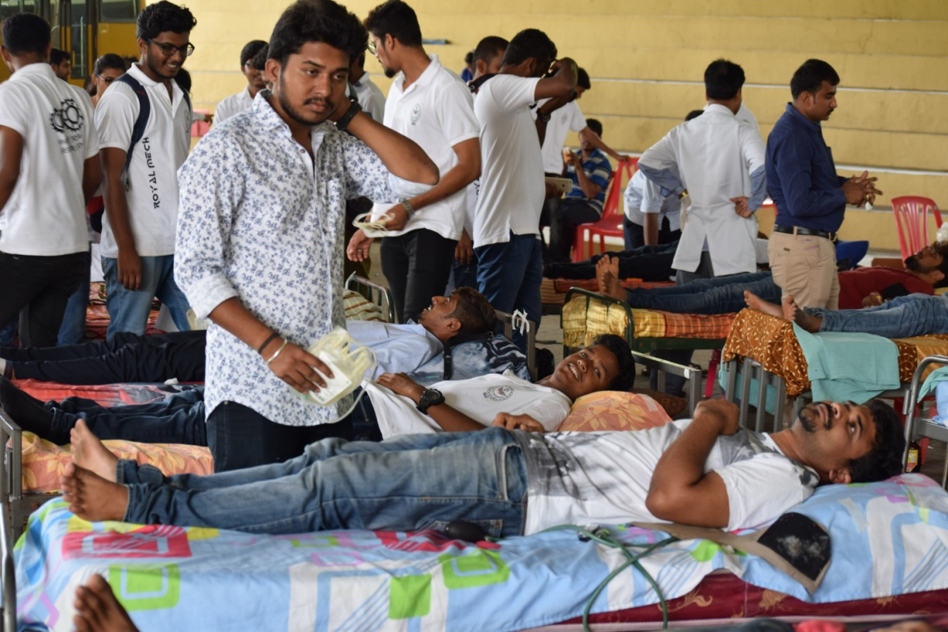

76 units of blood were collected and donated to Adichunchangiri Institute of Medical Sciences, Bellur Cross, Mandya.