5.1.2 – ICT ACTIVITIES

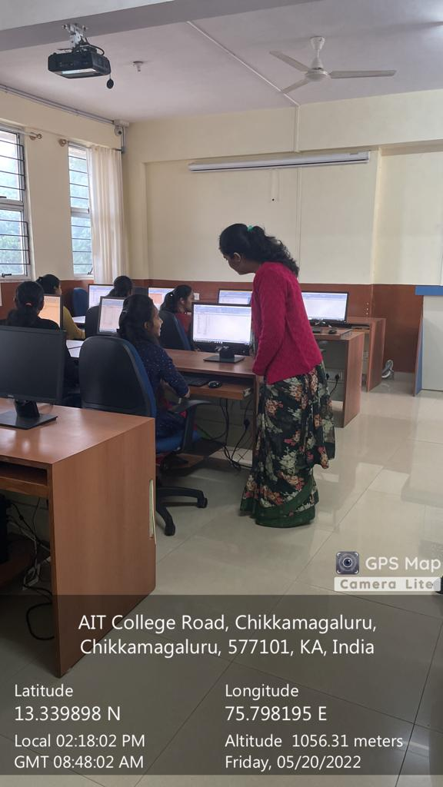

1. Resource Person: Mrs Aruna Saganali- Assistant Professor, Department of MBA,

Topic Covered: Preparation of tables and graph by using the data in excel.

Number of participates: 58 students

Date :20/05/2022

2.

. 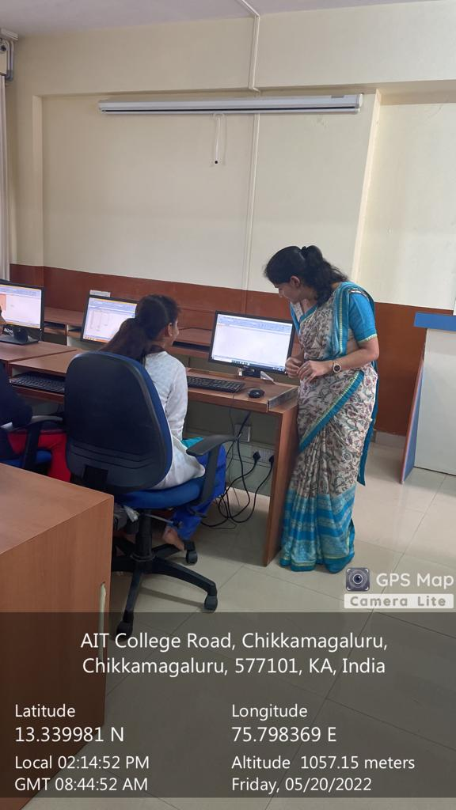

. Resource Person: Mrs Shambavi S M - Assistant Professor, Department of MBA,

Topic Covered: Preparation of power point presentation.

Number of participates: 58 students

Date: 20/05/2022

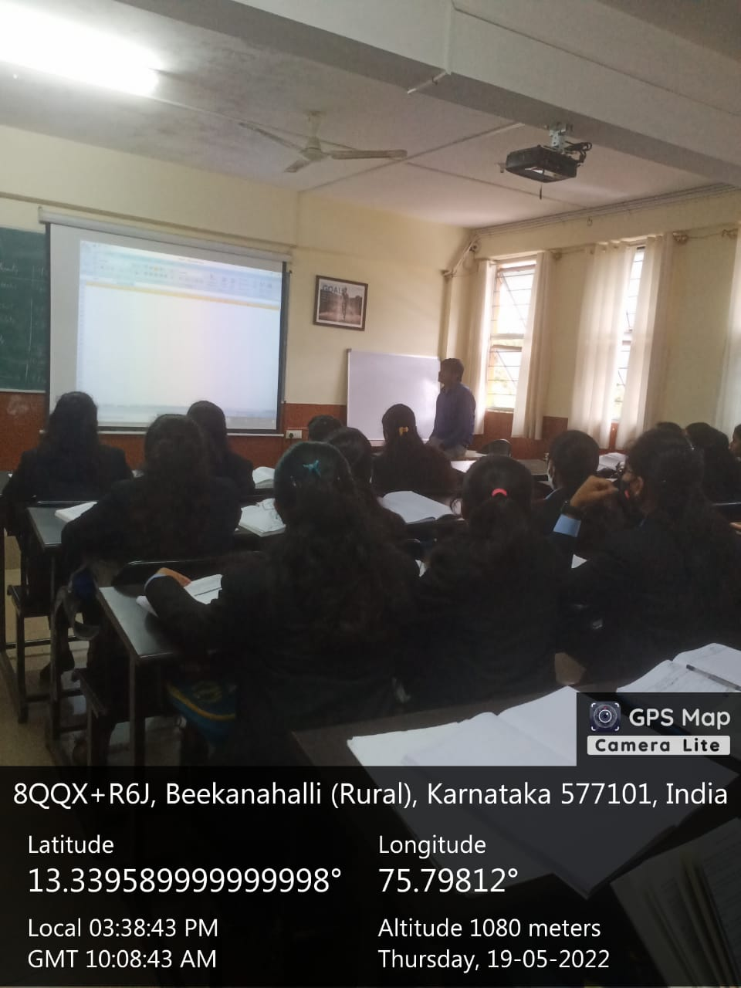

. Resource Person: Dr Devananda H M - Assistant Professor, Department of MBA,

Topic Covered: use of SSPS Software in final year project

Number of participates: 58 students

Date: 20/05/2022

Yoga and life Skill Activities

. Resource Person: Mrs Pavithra – Yoga Instructor, Brahmakumari Samaj, Chikkamagaluru

Topic Covered: It was conducted on occasion of international yoga day

Number of participates: 30 students

Date: 22/8/2022

